**FTO Report**

**Party B: CRO Co.**

**New Antibody Service Using SMALP**

2023/11/11

Total word count: 1492

(Without report contents, figures, tables and references)

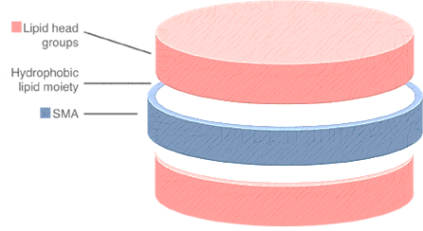

**Report Contents**

Table of Contents1

Brief Summary2

Background2

Launch Status Assessment2

Technical Feature2

SMA Synthesis Protocol2

Protein Solubilization and Formation of SMALPS 3

Related Patents4

Patent 44

Patent 114

Patent 124

Related Patents5

Similar Proportion of Precursor Substances with Patent 45

Similar Surfactant HLB and Size of SMALP of Patent 115

No Methodological similarity with Patent 125

Conclusion of Infringement Comparison5

Risk Aversion Suggestions6

Patent 46

Patent 117

Conclusion7

References8

**Brief Summary**

SMA copolymers also have a long-standing history in life sciences, originally being described as conjugates for drugs in cancer therapy (Maeda et al. 1979; Maeda 2001). Later, it was found that SMA can interact with phospholipids to form discoidal structures that can incorporate hydrophobic molecules and therefore would be useful as a drug delivery system (Tighe and Tonge 2000; Tonge and Tighe 2001). Based on this observation, new a.

**Background**

* 1. **Launch Status Assessment**

Object of this Freedom to Operate Report (FTO) is therapeutic antibody discovery services for membrane proteins using the technology of Styrene Maleic Acid Lipo-Protein (SMALP). The “*therapeutic antibody discovery services”* entrust us for this report is hereinafter referred to as **“*TADS”***.

Client in this case title of *CRO Co*., British organization *Contract Research Organization*. Potential market for this discovery service application is the UK market. Therefore, this FTO report will be written based on the principle of Section 60 of the *UK Patent Act.* Regarding the respect of infringement.

* 1. **Technical Feature**

**1.2.1** **SMA Synthesis Protocol**

Styrene–maleic acid (SMA) is the hydrolysed form of the styrene–maleic anhydride (SMAnh) copolymer in chemistry. When styrene(S) : maleic acid(Ma) molar ratio is 1:1, the reaction will generate SMA (see figure 1). Monomer sequence distribution in the polymer becomes more complex when S:Ma higher than 1:1 (Dorr et al. 2016).

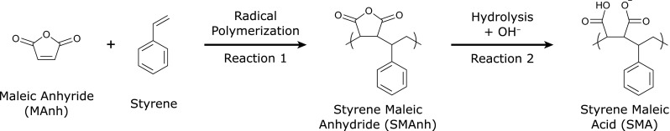

**Figure 1.** Synthesis of SMA (Dorr et al. 2016).

In scenario of *TADS*, precursor source will be come from commercially available acid anhydride period Netherlands *Inc. Polyscope* with a S: Ma ratio of 3:1 (*Xiran* *®*). It should be mentioned that in the reference protocol of TADS, Lee’s team use S:Ma ratio 2:1 as SMALP using S:Ma ratio 3:1 precursor contains bilayers, and the synthesis also begin from acid anhydride period (Lee et al.2016a). Then they use basic hydrolysis to dissolve styrene maleic anhydride (SMAnh) copolymer in 1M NaOH and react under solution heating and reflux.

The hydrophilicity lipophilicity balance (HLB) is a wildly used parameter that determines the degree of hydrophilicity or lipophilicity by calculating the molecular weight percentage of the hydrophilic (*Mh*, molecular mass of the hydrophilic part) and lipophilic parts of the surfactant molecule. The equation is shown below where *M* means molecular mass of the whole particle (Griffin et al, 1946).

Activation of SMA in *TADS* results in SMA product with HLB of 16.5 and some other by-product (see chart 1). The production can be store as a light white powder (Lee et al. 2016a).

|  |  |
| --- | --- |
| **By-product Substance** | **Proportion by Weight** |
| free monomic styrene | 0.25% |
| free monomer maleic acid plus maleic anhydride | 0.3% |

**Chart 1.** By-Product and Proportion in Basic Hydrolysis Synthase of TADS

**1.2.2** **Protein Solubilization and Formation of SMALPS**

SMAs is used in a promising approach to detergent-free solubilize membrane proteins (MP). Most of the other processes to dissolve MB require detergents to extract native MPs from cellular membranes (Dorr et al. 2016). Detergents always cause transient destabilization of MP.

SMAs exhibit a significantly different mode of action from detergents. Addition of SMAs to synthetic or biological lipid membranes leads to the spontaneous formation of disc-shaped particles with a diameter of approximately 10 nm (Jamshad et al. 2015). In this novel SMAs bound nano disk, the bilayer structure of the incorporated lipid molecules is stabilized(Orwick et al. 2012). It had different names from different research at early stages, but nowadays most used name right now is SMALPs (see chart 2).

|  |  |
| --- | --- |
| **Name** | **Related Research** |
| SMA–lipid particles (SMALPs) | Knowles et al. 2009 |
| Lipodisq particles | Orwick et al. 2012 |
| native nanodiscs | Dörr et al. 2014 |

**Chart 2.** Other names for the particles and related publication

Add powdered SMA polymer to membrane solution at a ratio of 1g:10g (Lee et all. 2016a), MP with up to 36 transmembrane domains will spontaneously form a 9-12nm diameter SMALP structure (Orwick et al. 2012; Knowles et al. 2009). Research proved that protein structure remained stable in SMALP. After that protein can still be purified directly by wildly used methods such as chromatography (Scheidelaar et al.2015; Dorr et al. 2016).

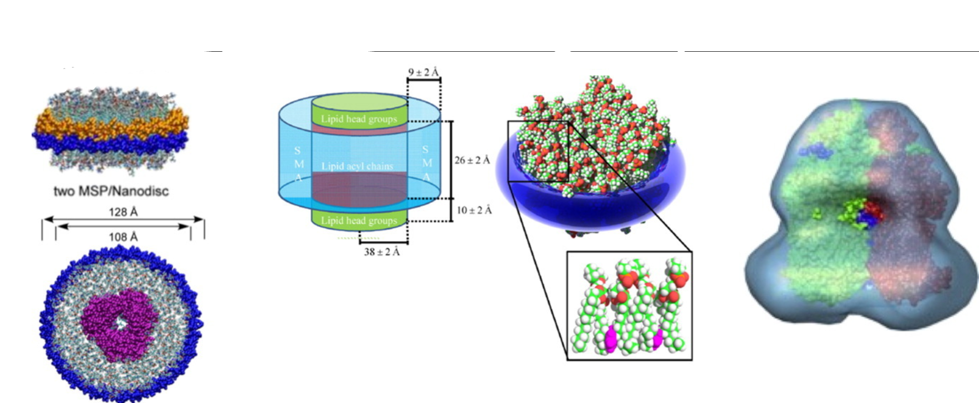

**Figure 2.** Comparison of membrane proteins in nano-discs. Shows MSP, lipid only SMALP, egative stain 3D reconstruction of SMALP from left to right (Lee et all. 2016b).

**Related Patents**

The search was conducted by a professional patent search company in PatBase. The most relevant from this comprehensive patent search are 3 patents (assumingly) granted in UK shown below.

**2.1 Patent 4**

WO2011/004158,

SOLUBILISATION OF MEMBRANE PROTEINS

This patent is published on 13 January 2011. It focusses on method to solubilise a membrane protein. It come from CTB-TTF project (Grant et al. 2005) Malvern group collaborate with Overduin’s group from University of Birmingham (UBir).

This method is applied to molecular in cell membrane including proteins and related lipids. It is done by mixing copolymer of 1:2 to 10:1 styrene and maleic acid, with cellular component to form soluble macromolecular assemblies of the copolymer, lipids, and proteins.

What we need to remind Party B is that the invertor of this patent is Timothy Dafforn, Michael Overduin, Timothy Knowles. Tim Dafforn is the corresponding author of the journal article from Nat Protocol “A method for detergent-free isolation of membrane proteins in their local lipid environment” (see Lee et al, 2016a). We will mention later that the synthesis method of Lee’s article, which is the method being used by party B in TADS, is indeed include in the patent 4.

**2.2 Patent 11**

*WO2008/065451,*

*COMPOSITIONS COMPRISING MACROMOLECULAR ASSEMBLIES OF LIPID AND SURFACTANT*

This patent is published on 5 June 2008. It is the originally patent of *SAMLP* although name of it is *Lipodisq*represent in the document.

It provides composition comprising lipids and surfactants. The surfactant in it has an HLB number of less than 20. The lipids and surfactants form the less than 100nm macromolecular assemblies.

**2.3 Patent 12**

*WO2007/115165*

*STYRENE-MALEIC ANHYDRIDE COPOLYMERS FOR BIOAPPLICATIONS AND THEIR PREPARATION*

This patent is published on 11 October 2007. It focusses on the solvent free technology to prepare SMA.

It is mentioned that solvent-free method results in a reduction in the amount of residue, such as unreacted styrene and/or maleic anhydride monomers, making copolymers particularly suitable for biological applications.

**Infringement Comparison**

**3.1** **Similar Proportion of Precursor Substances with Patent 4**

TADS used precursor of S:Ma=3:1 which infringe the property right of Patent 4.Patent 4 emphasized that all copolymer of styrene and maleic acid used in membrane protein solubilising wherein the styrene : maleic acid ratio is between 1:2 and 10:1 is against their claim 1.

**3.2 Similar Surfactant HLB and Size of SMALP of Patent 11**

In claim 1 of Patent 11, it is confirmed that all SMALP characterised in that the surfactant has an HLB number of less than 20 and in that the lipid and surfactant are in the form of macromolecular assemblies of less than 100 nm in diameter. TADS represent a surfactant HLB of 16.5 and Assembly Size of about 10 nm, which constitute infringement of patent 11.

**3.3 No Methodological similarity with Patent 12**

The patent 12 use solventless method to reduce the residence. They claim all styrene-maleic anhydride copolymer having less than 0.050% by weight unreacted styrene monomer (see claim 1). In scenario of TADS, it uses the method of traditional basic hydrolysis protocol with 0.25% unreacted styrene which is higher than patent 12. Patent 12 also claim styrene-maleic anhydride copolymer having less than 0.2% by weight unreacted maleic anhydride and maleic acid combined (see claim 2), and the ratio of TADS is 0.3% which is also higher (see chart 1). Therefore, Party B has not infringed Patent 12 from by-product ratio.

**3.4** **Conclusion of Infringement Comparison**

We can see that during the SMA synthesis period Party B did not constitute infringement of patent 12 as it used traditional processes with more residual product. However, it is likely to constitute infringement of patent 4 as its precursor material ratio is analogous. During the protein solubilization period, Party B presumably constitute infringement of patent 11 as their consistent chemical properties of SMAPL. (See chart 3)

|  |  |  |  |  |  |  |  |  |  |
| --- | --- | --- | --- | --- | --- | --- | --- | --- | --- |
|  | Possible Infringement Aspects | | | | | | | | |
| SMA Synthesis Method | IN | S: MA Ratio | IN | Surfactant  HLB | IN | Assembly Size | IN | Final |
| TADS | Basic Hydrolysis Protocol | - | 3:1 | - | 16.5 | - | ~10nm | 5 |
| Patent  4 | Basic Hydrolysis Protocol | N | 1:2 to 10:1 | Y | - | N | - | N | Y |
| Patent 11 | - | N | - | N | >20 | Y | >100nm | Y | Y |
| Patent 12 | Solventless Method | N | - | N | - | N | - | N | N |

**Chart 3.** Possible infringement aspects of TADS. IN stands for infringement. Y means there is infringement and N means no infringement. Yellow shading means the focus of the patent.

**Risk Aversion Suggestions**

**4.1 patent 4**

|  |  |  |
| --- | --- | --- |
|  | **Technological Option** | **Commercial Option** |
| Risk Aversion Suggestion | 1A. To make S:Ma ratio <1:2  1B. To make S:Ma ratio >10:1. | 2A. Exclusive license  2B. Cross licence  2C. Non-exclusive license  2D. Technology shares  Here, business department of the company should provide specific profit models and expected funding for further analysis.  If SMALP does not involve key profitability, then 2C and 2D option will be more effective. Negotiation with UBir for exclusive licence is not excluded if bid is good and Party B is adequately capitalised. Our evaluation recognizes the potential commercial value of Patent 4.  The Intellectual Property and Commercialisation (IPaC) team of UBir limit grants of IP from professor to funder. It is recommended that the board not only hire Prof. Dafforn et al. as consultant, but also establish an interest binding long-term relationship with the UBir. |
| Feasibility  Analysis | Most research indicated that SMA (3:1) is the best ratio of SMALP solubilization effectiveness and downstream stability (Hall et al. 2018). SMA (3:1) display highest intensity of hydrophobic/ lipophilic balance required for complete dissolution of lipid bilayers. There is no current literature evidence to suggest that <1/2 StMA or >10/1StMa still have solubility. It is analysed that the former is completely hydrophilic while later is hydrophobic (Juan et al. 2019).  **Figure 3**. StMA means styrene-maleic acid. (Andrew et al. 2016) |
| Recommendations to the Board | Base on the above analysis, the technological option can be ruled out. There is no need to waste company costs in order to experimentally verify the substrate ratio excluded by patent 4.  This report preferent recommendation to the board is **not to avoid patent 4**, but by commercial approach. We support negotiating with university directors and patent holders whether they can hold project shares or grant us non-exclusive license. | |

**4.1 patent 11**

|  |  |  |
| --- | --- | --- |
|  | **Technological Option** | **Commercial Option** |
| Risk Aversion Suggestion | 1A. To make HLB>20  1B. To make SMALP>100nm. | 2A. Exclusive license  2B. Cross licence  2C. Non-exclusive license  2D. Technology shares  Here, business department of the company should provide specific profit models and expected funding for further analysis. |
| Feasibility  Analysis |  |
| Recommendations to the Board | Base on the above analysis, the technological option can be ruled out. There is no need to waste company costs in order to experimentally verify the substrate ratio excluded by patent 4.  This report preferent recommendation to the board is **not to avoid patent 4**, but by commercial approach. We support negotiating with university directors and patent holders whether they ca hold project shares or grant us non-exclusive license. | |

**Conclusion**

**Reference**

Bada Juarez, J.F., Harper, A.J., Judge, P.J., Tonge, S.R. and Watts, A., 2019. 'From polymer chemistry to structural biology: The development of SMA and related amphipathic polymers for membrane protein extraction and solubilisation', Chem Phys Lipids, 221, 167-175.

Dörr, J.M., Scheidelaar, S., Koorengevel, M.C., Dominguez, J.J., Schäfer, M., van Walree, C.A. and Killian, J.A., 2016. 'The styrene-maleic acid copolymer: a versatile tool in membrane research', Eur Biophys J, 45(1), 3-21.

Griffin, W.C., 1946. 'Classification of surface-active agents by "HLB"', in.

Grant, 2005.Central Technology Belt Technology Transfer Fund: Project ID: 0001.05; Nanodiscs for Drug Screening. Partners, University of Birmingham & Malvern Cosmeceutics Ltd.

Hall, S.C.L., Tognoloni, C., Price, G.J., Klumperman, B., Edler, K.J., Dafforn, T.R. and Arnold, T. (2018) 'Influence of Poly (styrene- co-maleic acid) Copolymer Structure on the Properties and Self-Assembly of SMALP Nanodiscs', Biomacromolecules, 19(3), 761-772.

Jamshad, M., Grimard, V., Idini, I., Knowles, T.J., Dowle, M.R., Schofield, N., Sridhar, P., Lin, Y.P., Finka, R., Wheatley, M., Thomas, O.R., Palmer, R.E., Overduin, M., Govaerts, C., Ruysschaert, J.M., Edler, K.J. and Dafforn, T.R. 2015, 'Structural analysis of a nanoparticle containing a lipid bilayer used for detergent-free extraction of membrane proteins', Nano Res, 8(3), 774-789.

Knowles, T.J., Finka, R., Smith, C., Lin, Y.P., Dafforn, T. and Overduin, M.,2009. 'Membrane proteins solubilized intact in lipid containing nanoparticles bounded by styrene maleic acid copolymer', J Am Chem Soc, 131(22), 7484-5.

Lee, S.C., Khalid, S., Pollock, N.L., Knowles, T.J., Edler, K., Rothnie, A.J., O, R.T.T. and Dafforn, T.R, 2016a. 'Encapsulated membrane proteins: A simplified system for molecular simulation', Biochim Biophys Acta, 1858(10), 2549-2557.

Lee, S.C., Knowles, T.J., Postis, V.L., Jamshad, M., Parslow, R.A., Lin, Y.P., Goldman, A., Sridhar, P., Overduin, M., Muench, S.P. and Dafforn, T.R, 2016b. 'A method for detergent-free isolation of membrane proteins in their local lipid environment', Nat Protoc, 11(7), 1149-62.

Orwick, M.C., Judge, P.J., Procek, J., Lindholm, L., Graziadei, A., Engel, A., Gröbner, G. and Watts, A, 2012. 'Detergent-free formation and physicochemical characterization of nanosized lipid-polymer complexes: Lipodisq', Angew Chem Int Ed Engl, 51(19), 4653-7.

Orwick-Rydmark, M., Lovett, J.E., Graziadei, A., Lindholm, L., Hicks, M.R. and Watts, A. 2012. 'Detergent-free incorporation of a seven-transmembrane receptor protein into nanosized bilayer Lipodisq particles for functional and biophysical studies', Nano Lett, 12(9), 4687-92.

Scheidelaar, S., Koorengevel, M.C., Pardo, J.D., Meeldijk, J.D., Breukink, E. and Killian, J.A. 2015. 'Molecular model for the solubilization of membranes into nanodisks by styrene maleic Acid copolymers', Biophys J, 108(2), 279-90.